*Sixth Sunday after Epiphany ~ February 19, 2023*



**WELCOME TO WORSHIP!**

This week we learn that Jesus came to free us from sin. He did not come to free us to sin. The commands in the readings remind us just how holy our God is, and their dire warnings remind us just how holy he wants us to be. That can lead us to despair but we are reminded that the Lord has taken away our sin and by the power of the Holy Spirit we can lead God-pleasing lives.

**PRAYER BEFORE WORSHIP**

Lord, we confess our sins to you and plead for your mercy. We acknowledge that sin runs too deep in our nature for us ever to rid ourselves of it, but we thank you that Jesus has done what we could not do, washing us clean of every stain. We plead that your Spirit would give us the strength to live a new life; through Christ our Lord. Amen.

Acknowledgments

Setting One from Christian Worship

Unless otherwise indicated, Scripture quotations are from The Holy Bible, New International Version®, NIV®. Copyright © 1973, 1978, 1984, 2011 by Biblica, Inc.TM Used by permission of Zondervan. All rights reserved worldwide.

Software distributed in partnership with Northwestern Publishing House.

Created by Christian Worship: Service Builder © 2023 Concordia Publishing House.

SERVING IN WORSHIP TODAY

* Minister – Vicar Caleb Gustafson
* Organist – Marie Kurth
* Ushers – Sawyer Burish, Bob Gresens

*(Next Sunday – Tim & Ellen Heil)*

Our Worship

Opening Hymn CW 697

1 May we your precepts, Lord, fulfill  
and do on earth our Father’s will  
 as angels do above;  
still walk in Christ, the living way,  
with all your children, and obey  
 the law of Christian love.

2 So may we join your name to bless,  
your grace adore, your pow’r confess,  
 to flee from sin and strife.  
One is our calling, one our name,  
the end of all our hopes the same:  
 a glorious crown of life.

3 Spirit of life, of love, and peace,  
unite our hearts, our joy increase,  
 your gracious help supply.  
To each of us the blessing give  
in Christian fellowship to live,  
 in joyful hope to die.

Text: Edward Osler, 1789–1863, alt.  
Text: Public domain

Stand

In the name of the Father and of the T Son and of the Holy Spirit.

**Amen.**

Blessed are they whose transgressions are forgiven, whose sins are covered.

**Blessed are they whose sin the Lord does not count against them.**

Let us confess our sins to the Lord.

**Almighty and merciful Father, we have strayed from your ways like lost sheep. We have followed what we have devised and desired in our hearts. We have offended you and sinned against your holy law. We have done those things that we should not have done, and we have not done those things that we should have done. Have mercy on us, Lord! Spare us, forgive us, and restore us,**   
**according to your promises in Christ Jesus.**

God, our merciful Father, has forgiven all our sins. He sent his Son, Jesus Christ, to be our Redeemer and Savior. Jesus paid the penalty for our guilt by his death on the cross and freed us from death by his resurrection from the grave. We have peace with God now and forever.

**Amen.**

916 Today Your Mercy Calls Us CW 916 sts. 1–2

1 Today your mercy calls us  
 to wash away our sin.  
However great our trespass,  
 whatever we have been,  
however long from mercy  
 our hearts have turned away,  
your precious blood can wash us  
 and make us clean today.

2 Today your gate is open,  
 and all who enter in  
shall find a Father’s welcome  
 and pardon for their sin.  
The past shall be forgotten,  
 a present joy be giv’n,  
a future grace be promised,  
 a glorious crown in heav’n.

Text: Oswald Allen, 1816–1878, alt.  
Text: Public domain

# The Word

The Lord be with you.

**And also with you.**

Prayer of the Day

Lord God, in mercy receive the prayers of your people. Grant them the wisdom to know the things that please you and the grace and power always to accomplish them; through your Son, Jesus Christ our Lord, who lives and reigns with you and the Holy Spirit, one God, now and forever.

**Amen.**

Be seated

First Reading 2 Samuel 11:1–17,26-27

1In the spring, at the time when kings go off to war, David sent Joab out with the king’s men and the whole Israelite army. They destroyed the Ammonites and besieged Rabbah. But David remained in Jerusalem.

2One evening David got up from his bed and walked around on the roof of the palace. From the roof he saw a woman bathing. The woman was very beautiful, 3and David sent someone to find out about her. The man said, “She is Bathsheba, the daughter of Eliam and the wife of Uriah the Hittite.” 4Then David sent messengers to get her. She came to him, and he slept with her. (Now she was purifying herself from her monthly uncleanness.) Then she went back home. 5The woman conceived and sent word to David, saying, “I am pregnant.”

6So David sent this word to Joab: “Send me Uriah the Hittite.” And Joab sent him to David. 7When Uriah came to him, David asked him how Joab was, how the soldiers were and how the war was going. 8Then David said to Uriah, “Go down to your house and wash your feet.” So Uriah left the palace, and a gift from the king was sent after him. 9But Uriah slept at the entrance to the palace with all his master’s servants and did not go down to his house.

10David was told, “Uriah did not go home.” So he asked Uriah, “Haven’t you just come from a military campaign? Why didn’t you go home?”

11Uriah said to David, “The ark and Israel and Judah are staying in tents, and my commander Joab and my lord’s men are camped in the open country. How could I go to my house to eat and drink and make love to my wife? As surely as you live, I will not do such a thing!”

12Then David said to him, “Stay here one more day, and tomorrow I will send you back.” So Uriah remained in Jerusalem that day and the next. 13At David’s invitation, he ate and drank with him, and David made him drunk. But in the evening Uriah went out to sleep on his mat among his master’s servants; he did not go home.

14In the morning David wrote a letter to Joab and sent it with Uriah. 15In it he wrote, “Put Uriah out in front where the fighting is fiercest. Then withdraw from him so he will be struck down and die.”

16So while Joab had the city under siege, he put Uriah at a place where he knew the strongest defenders were. 17When the men of the city came out and fought against Joab, some of the men in David’s army fell; moreover, Uriah the Hittite died.

26When Uriah’s wife heard that her husband was dead, she mourned for him. 27After the time of mourning was over, David had her brought to his house, and she became his wife and bore him a son. But the thing David had done displeased the Lord.

Psalm of the Day Psalm 119A

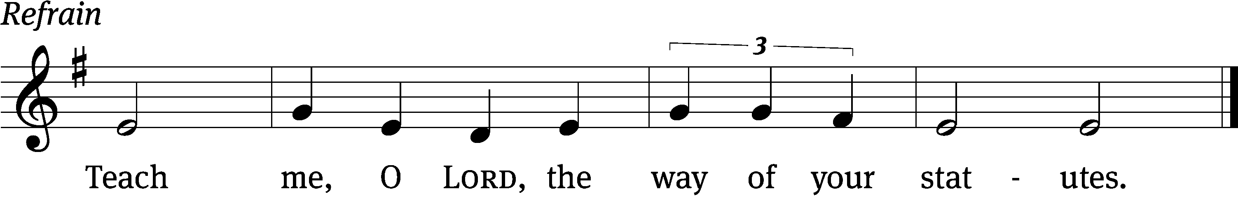

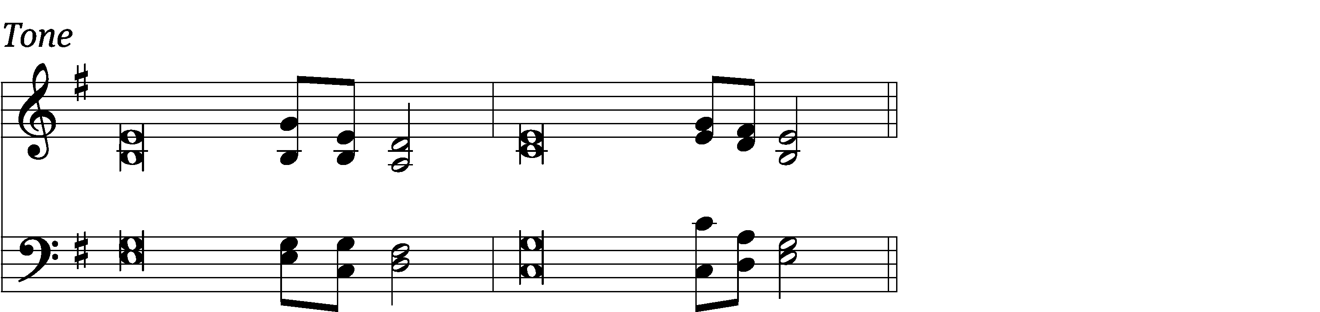

Blessed are those whose ways are / blameless,  
 who walk according to the law / of the Lord.  
Blessed are those who keep his / statutes  
 and seek him with / all their heart.  
You have laid down / precepts  
 that are to be ful- / ly obeyed. *Refrain*

Oh, that my ways were / steadfast  
 in obeying / your decrees!  
Then I would not be / put to shame  
 when I consider all / your commands.  
I will praise you with an / upright heart  
 as I learn your / righteous laws.  
**Glory be to the Father and** / **to the Son**  
 **and to the Holy** / **Spirit,**  
**as it was in the be-** / **ginning,**  
 **is now, and will be forever.** / **Amen.** *Refrain*

Tune: Thomas Pavlechko Setting: Thomas Pavlechko  
Music: © 2004, 2012 Augsburg Fortress. Used by permission: OneLicense no. 716671

Second Reading 1 Thessalonians 4:1–12

1As for other matters, brothers and sisters, we instructed you how to live in order to please God, as in fact you are living. Now we ask you and urge you in the Lord Jesus to do this more and more. 2For you know what instructions we gave you by the authority of the Lord Jesus.

3It is God’s will that you should be sanctified: that you should avoid sexual immorality; 4that each of you should learn to control your own body in a way that is holy and honorable, 5not in passionate lust like the pagans, who do not know God; 6and that in this matter no one should wrong or take advantage of a brother or sister. The Lord will punish all those who commit such sins, as we told you and warned you before. 7For God did not call us to be impure, but to live a holy life. 8Therefore, anyone who rejects this instruction does not reject a human being but God, the very God who gives you his Holy Spirit.

9Now about your love for one another we do not need to write to you, for you yourselves have been taught by God to love each other. 10And in fact, you do love all of God’s family throughout Macedonia. Yet we urge you, brothers and sisters, to do so more and more, 11and to make it your ambition to lead a quiet life: You should mind your own business and work with your hands, just as we told you, 12so that your daily life may win the respect of outsiders and so that you will not be dependent on anybody.

Stand

Gospel Acclamation Ephesians 5:2

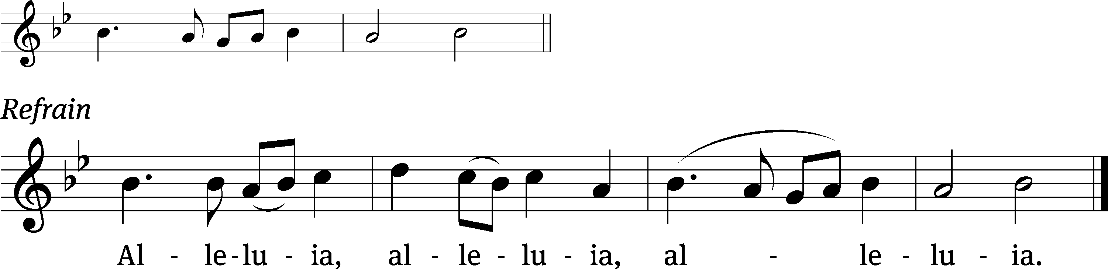

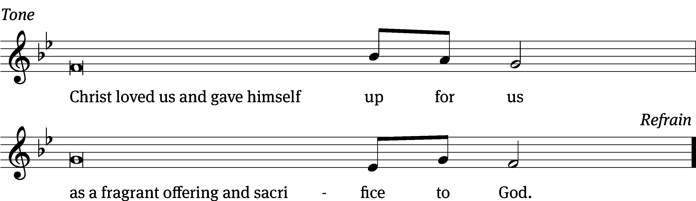

Tune: © 2021 Northwestern Publishing House. Used by permission: OneLicense no. 716671

Gospel Matthew 5:21–37

21“You have heard that it was said to the people long ago, ‘You shall not murder, and anyone who murders will be subject to judgment.’ 22But I tell you that anyone who is angry with a brother or sister will be subject to judgment. Again, anyone who says to a brother or sister, ‘Raca,’ is answerable to the court. And anyone who says, ‘You fool!’ will be in danger of the fire of hell.

23“Therefore, if you are offering your gift at the altar and there remember that your brother or sister has something against you, 24leave your gift there in front of the altar. First go and be reconciled to them; then come and offer your gift.

25“Settle matters quickly with your adversary who is taking you to court. Do it while you are still together on the way, or your adversary may hand you over to the judge, and the judge may hand you over to the officer, and you may be thrown into prison. 26Truly I tell you, you will not get out until you have paid the last penny.

27“You have heard that it was said, ‘You shall not commit adultery.’ 28But I tell you that anyone who looks at a woman lustfully has already committed adultery with her in his heart. 29If your right eye causes you to stumble, gouge it out and throw it away. It is better for you to lose one part of your body than for your whole body to be thrown into hell. 30And if your right hand causes you to stumble, cut it off and throw it away. It is better for you to lose one part of your body than for your whole body to go into hell.

31“It has been said, ‘Anyone who divorces his wife must give her a certificate of divorce.’ 32But I tell you that anyone who divorces his wife, except for sexual immorality, makes her the victim of adultery, and anyone who marries a divorced woman commits adultery.

33“Again, you have heard that it was said to the people long ago, ‘Do not break your oath, but fulfill to the Lord the vows you have made.’ 34But I tell you, do not swear an oath at all: either by heaven, for it is God’s throne; 35or by the earth, for it is his footstool; or by Jerusalem, for it is the city of the Great King. 36And do not swear by your head, for you cannot make even one hair white or black. 37All you need to say is simply ‘Yes’ or ‘No’; anything beyond this comes from the evil one.

The Gospel of the Lord.

**Praise be to you, O Christ!**

Be seated

Children's Message

Hymn of the Day CW 696

1 Take my life and let it be consecrated, Lord, to thee;  
take my moments and my days, let them flow in ceaseless praise,  
let them flow in ceaseless praise.

2 Take my hands and let them move at the impulse of thy love;  
take my feet and let them be swift and beautiful for thee,  
swift and beautiful for thee.

3 Take my voice and let me sing always, only for my King;  
take my lips and let them be filled with messages from thee,  
filled with messages from thee.

4 Take my silver and my gold, not a mite would I withhold;  
take my intellect and use ev’ry pow’r as thou shalt choose,  
ev’ry pow’r as thou shalt choose.

5 Take my will and make it thine, it shall be no longer mine;  
take my heart, it is thine own, it shall be thy royal throne,  
it shall be thy royal throne.

6 Take my love, my Lord, I pour at thy feet its treasure store;  
take myself, and I will be ever, only, all for thee,  
ever, only, all for thee.

Text: Frances R. Havergal, 1836–1879  
Text: Public domain

Sermon 2 Samuel 11; selected verses

*David: Not the Ideal Role-Model*

Apostles’ Creed

**I believe in God, the Father Almighty, maker of heaven and earth.**

**I believe in Jesus Christ, his only Son, our Lord, who was conceived by the Holy Spirit, born of the Virgin Mary, suffered under Pontius Pilate, was crucified, died, and was buried. He descended into hell. The third day he rose again from the dead. He ascended into heaven and is seated at the right hand of God the Father Almighty. From there he will come to judge the living and the dead.**

**I believe in the Holy Spirit, the holy Christian Church, the communion of saints, the forgiveness of sins, the resurrection of the body, and the life everlasting. Amen.**

Thank Offering & Friendship Register

*As the offering is gathered, we ask both members and visitors to sign the Friendship Registers, which are located at the end of the pews. Guests are welcome to give but should not feel obligated to do so.*

Prayer of the Church

Almighty God and Father, we thank you for all your mercies, especially for the gift of your Son, through whom you have revealed your gracious will. We praise you for the Holy Spirit and his working through the means of grace.

**Plant your Word in our hearts, and cause it to produce fruit in our lives.**

Strengthen and defend your Church, that by your Word and sacraments faith may grow and love toward all may increase.

**Support all who spread the light of your truth throughout the world.**

Keep our children in the grace of their baptisms. Enable their parents to train them in lives of faith.

**Raise up Christians to serve you in the ministry of the Word and in all godly walks of life.**

Preserve our nation in justice and honor. Guide and bless all who make, administer, and judge our laws.

**Give them wisdom that they may promote justice and hinder evil.**

Let your blessing rest on planting and harvest, commerce and industry, medicine and science, the arts and culture. Protect all who travel, and care for those whose work is difficult or dangerous.

**Be with all who devote themselves to any useful task.**

Comfort all who are in sorrow or need, sickness or adversity. Remember those who suffer persecution for the faith. Have mercy on those for whom death draws near.

**Grant them your love, and take them into your tender care.**

*Special prayers and intercessions*

Grant us these things, Father, for the sake of Jesus, who died and rose again. **Amen.**

Lord’s Prayer

**Our Father in heaven, hallowed be your name, your kingdom come, your will be done on earth as in heaven. Give us today our daily bread. Forgive us our sins, as we forgive those who sin against us. Lead us not into temptation, but deliver us from evil.**

**For the kingdom, the power, and the glory are yours now and forever. Amen.**

Blessing

The Lord bless you and keep you.

The Lord make his face shine on you and be gracious to you.

The Lord look on you with favor and T give you peace.

**Amen.**

Closing Hymn CW 835

*Precious Lord, Take My Hand*

.

***______________________________________________________***

***Thank you for worshiping with us!***

***May God richly bless your week.***

_________________________________________________________________________________

**Serving the Pastoral Vacancy -** Pastor Jeff Mahnke from St. Peter Lutheran Church is serving as Our Savior’s vacancy pastor.  Should you need his pastoral guidance and service, call / text him anytime at 715.297.0132.  His email address is [pastorm@mysaintpeter.org](mailto:pastorm@mysaintpeter.org).

**The Ideal Congregation** – This Sunday we begin a new adult Bible Class after worship that’s titled “The Ideal Congregation”.  Today’s emphasis:  the Church is God’s garden.  May God guide the ministry of Our Savior’s as we study and follow his Word!

**This Week: Ash Wednesday** – Lent begins with Ash Wednesday on **February 22nd**. A special service with Holy Communion will be held at Our Savior’s at 1:00 pm. Weekly midweek Lent services will be held on the five following Wednesdays (March 1, 8, 15, 22, 29) at 1:00 pm as we trace Jesus’ final steps to the cross and empty tomb.

We will follow the same pastoral rotation as St. Peter. If you can’t attend our afternoon services, please consider worshiping at a sister congregation. St. Peter’s Ash Wednesday services are on Wednesday at 4:30 & 7:00, and then for the rest of Lent the service time switches to Thursdays at 5:00 & 7:00 pm. Mountain of the Lord’s services are on Wednesdays at 6:00 pm.

**Help Hanging Lenten Banners –** We need a couple “younger” folks who can safely climb a ladder and help hang our Lent banners on Feb. 20 or 21. Please call Sue Unruh or Jan Gresens to volunteer.

**Call Meeting on Feb. 23 –**All members, especially our voters, are encouraged to attend our next Call meeting on Thursday, Feb. 23 at 5:00 pm. Come for the school basketball game (Parents Night) at 4:00 pm and stay for the meeting.

**Encourage One Another** – Please mark your calendar for Sunday, March 12th. After worship and Bible Class, members of Our Savior’s will join our leaders in going to the homes of members of our church family who are straying from worship because of covid and our lengthy pastoral vacancy.  Our visits won’t last long as we simply express our love and give our brothers and sisters in Christ our encouragement to return.  For planning purposes and since we want to provide a light lunch, we need to know if you can help.  Sign up by calling Marie in the church office or by using the sign up sheet in the entryway.  May the Lord bless this effort!

**Memorials**

We thank our members for gifts given in memory of Suzanne Durkee:

Bob & Janice Gresens, Mark & Beth Krohn, Rick & Karen Leopold,

Angie Marquis, Bill & Sue Unruh.

*Blessed be her memory.*

*Thanks be to God for the love which led to these gifts.*

|  |  |  |
| --- | --- | --- |
| **Today** | 9:00 AM  10:15 AM | Worship / WELS Connection  Sunday School & Bible Class |
| **Tuesday** | 5:00 PM | OSS Basketball at Zion, Rhinelander |
| **Wednesday** | 1:00 PM | **Ash Wednesday**  Worship with Holy Communion |
| **Thursday** | 4:00 PM  5:00 PM | OSS Home Basketball vs St. Peter  Pastoral Call Meeting |
| **Saturday** |  | OS Day at Dime & Dollar  NLHS Grade School Basketball Tourney |
| **Sunday 2/19** | 9:00 AM  10:15 AM | Worship with Communion  Sunday School & Bible Class |

**This Week at Our Savior’s**

**Together We Shine! –**  Northland LHS’ favorite annual fundraising event is right around the corner.  Together We Shine will be held on Sunday, March 5, beginning at noon.  Please consider donating something for our auction:  a unique item or craft goods, gift cards, tickets to some exciting destination, trips, or service vouchers.  We will also hold our annual Soup Cook-off:  call and register yourself or your team to represent your congregation, and stew up your best concoction!  Please be prepared with a second choice when registering, so we get a wide variety of choices, and plan to bring an electric roaster full.  Prizes will be awarded for best soups (the Golden Ladle, Silver Ladle, and Bronze Ladle) as well as the first roaster finished (Empty Bowl Award).  Call the office 715-359-3400 or email [nlhsoffice@nlhs.org](mailto:nlhsoffice@nlhs.org) with your donations, reservations, soup entry.

**Growing Together**

***February 12, 2023***

Weekly Vision Debt Red Memorial Plate Ash Wednesday

$9,248.00 $400.00 $420.00 $10.00 $15.00 $20.00

NLHS Op OS School Missions Church Equipment Chr Life Resources

$250.00 $10.00 $195.00 $250.00 $10.00

School Fees Magic Paper Box Gym Rental

$5,543.07.00 $32.00 $499.50

**Anticipated Weekly Offerings $4,038**

**Attendance:**  74 + 14 (online) = 88

**Our Savior’s Ev. Lutheran Church**

703 Flieth St, Wausau WI 54401

715-845-3253

Email: OSInfo@oursaviorswausau.org

Website: [www.oursaviorswausau.org](http://www.oursaviorswausau.org)

Facebook: Our Savior’s Lutheran Church and School

**Pastor Jeff Mahnke, Vacancy Pastor**

715-297-0132

[pastorm@mysaintpeter.org](mailto:pastorm@mysaintpeter.org)

